**All the scripts are uploaded in below path**

**https://github.com/jeswinjosejj005/jjrepo.git**

**Terraform plan master----success**

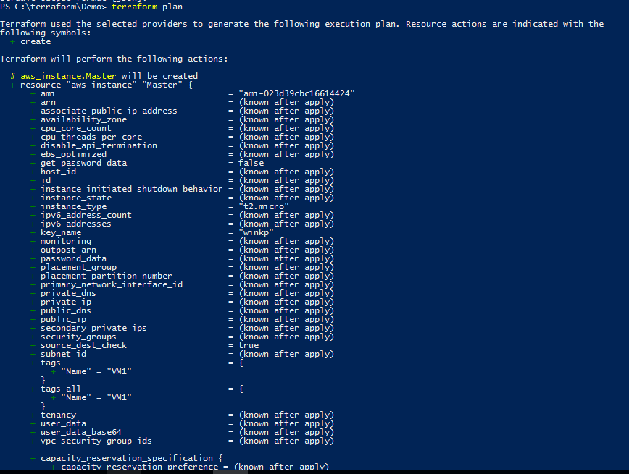

**Terraform plan slave------success**

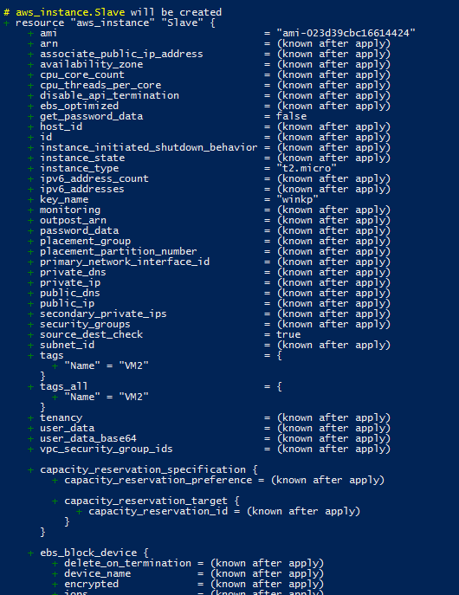

**Terraform Validate------success**

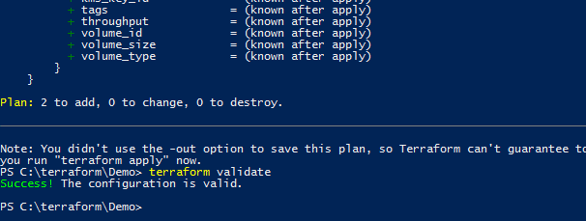

**Terraform apply-----success**

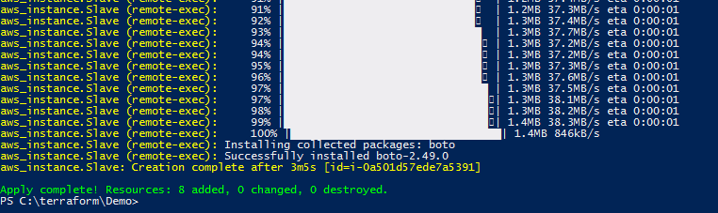

**2 vms (vm1 and vm2) successfully created with all the required configurations.**

**Jenkins configuration**

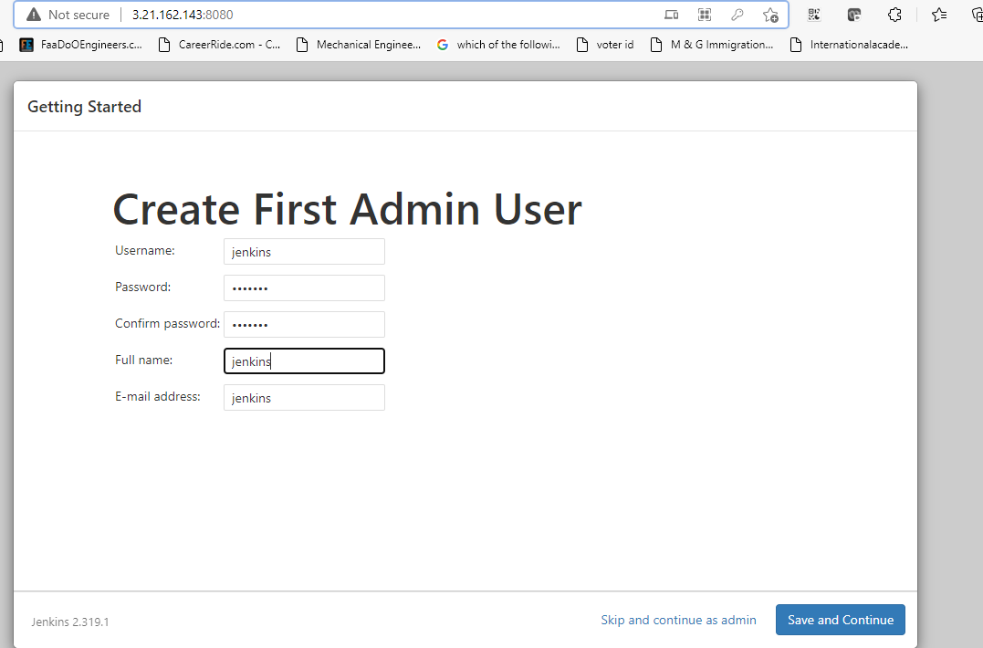

**Configured VM2**

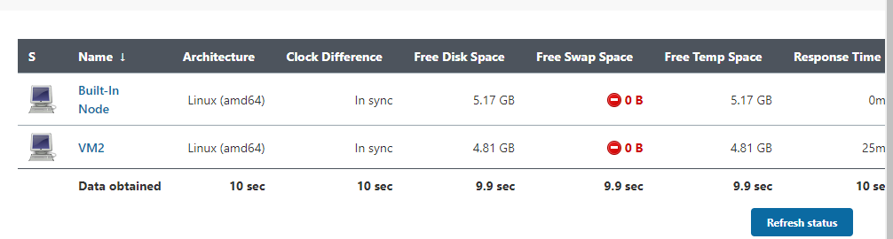

**Maven project with webapp**

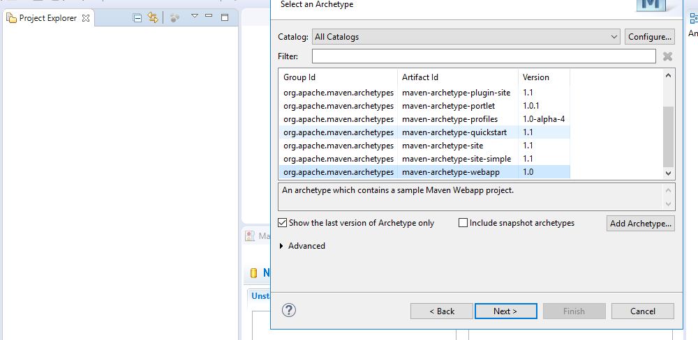

**Custom message**

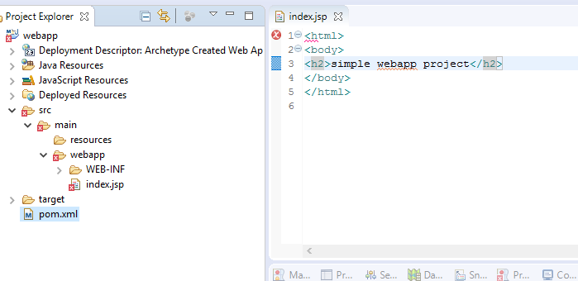

**Maven Clean install**

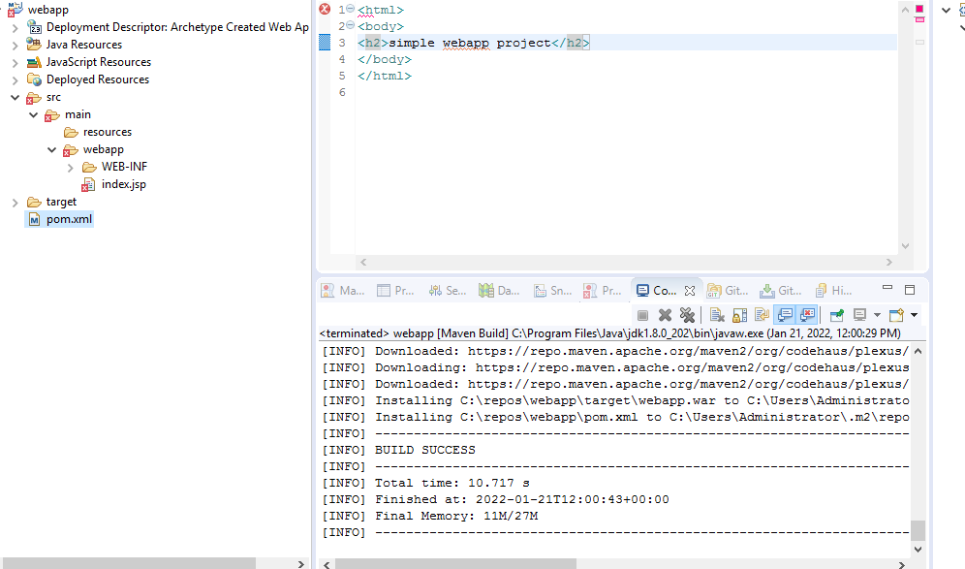

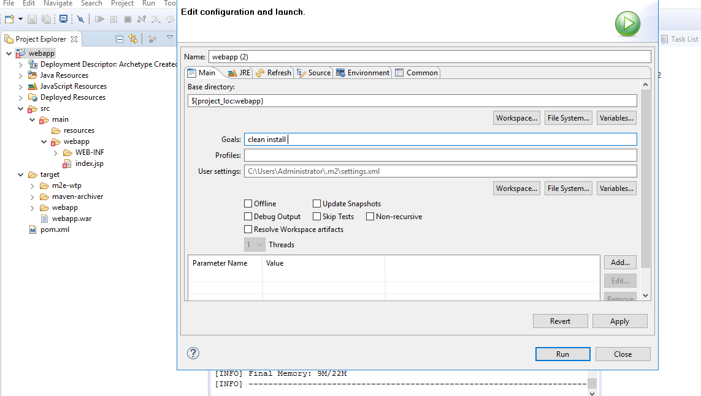

**War file generated**

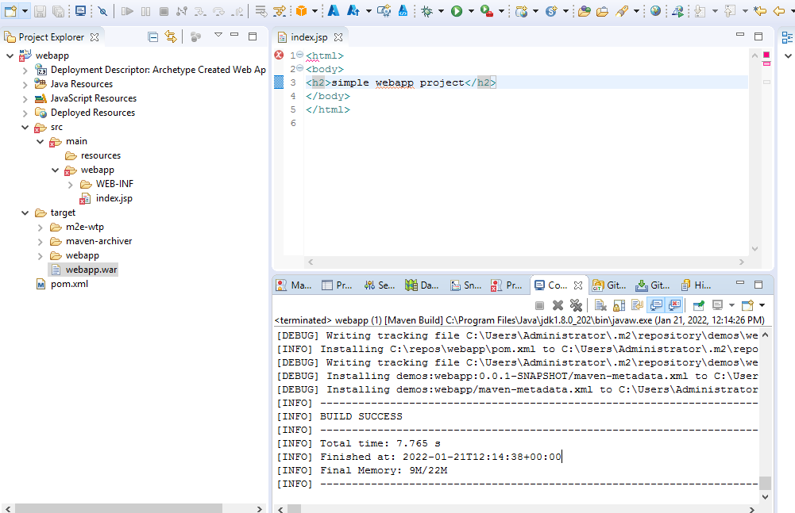

**Dockerfile tomcat**

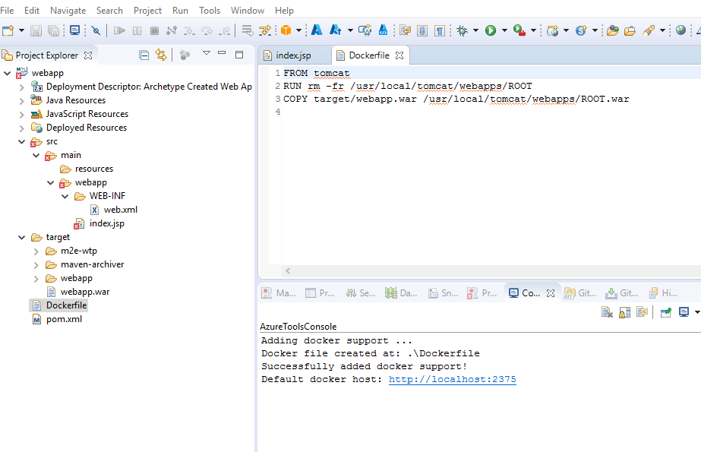

**Copying webapp to VM1 through winscp**

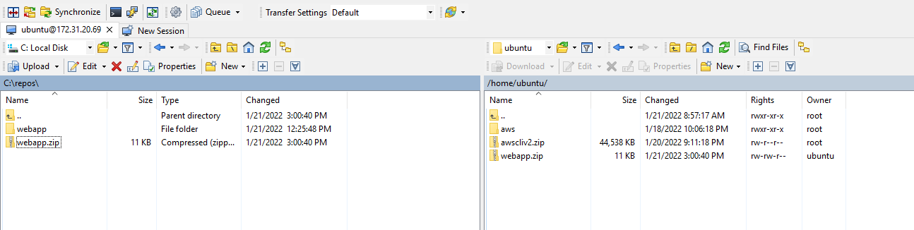

**Extracting war**

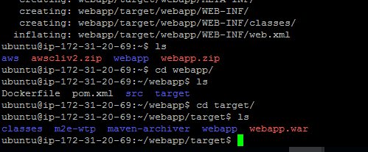

**Docker image containerization**

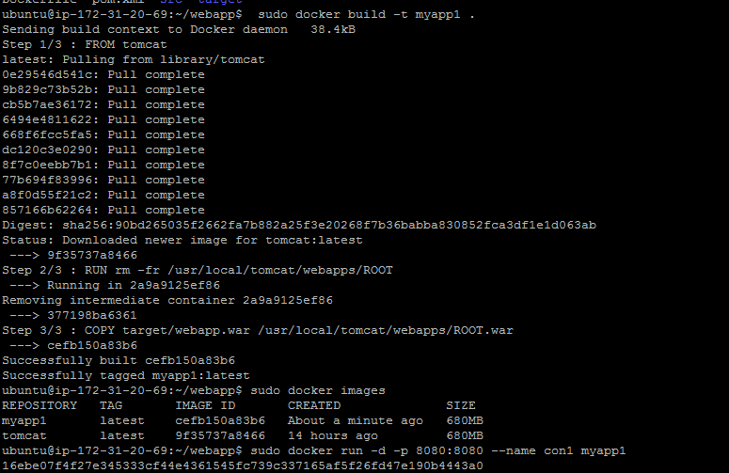

**Successful Container output**

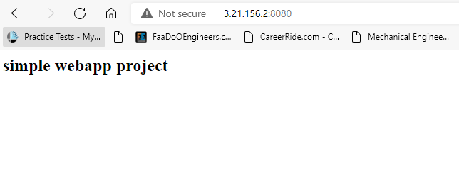

**Created git repo**

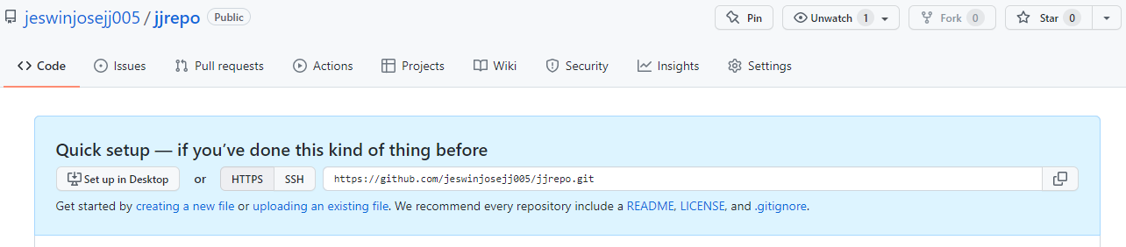

**Converting eclipse to Local repo**

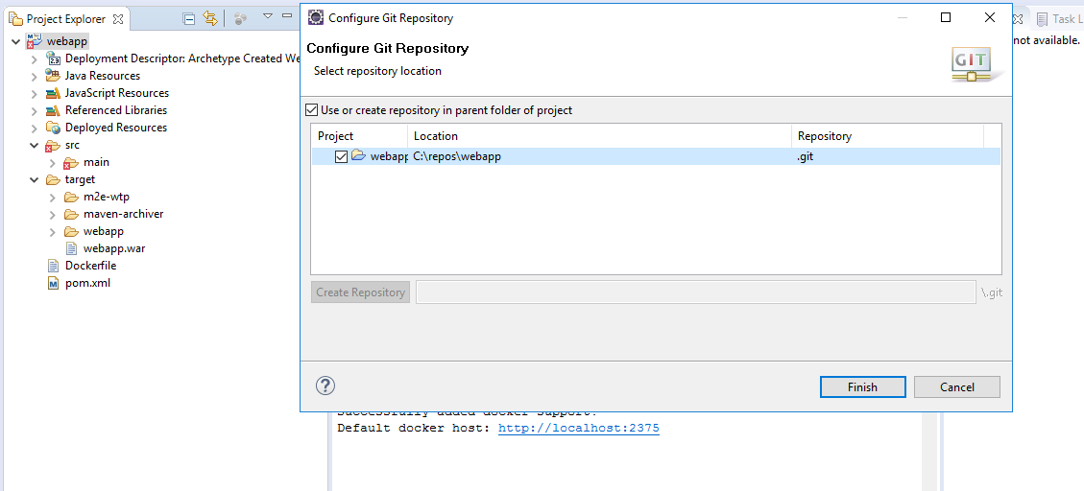

**Pushing local repo to remote repo**

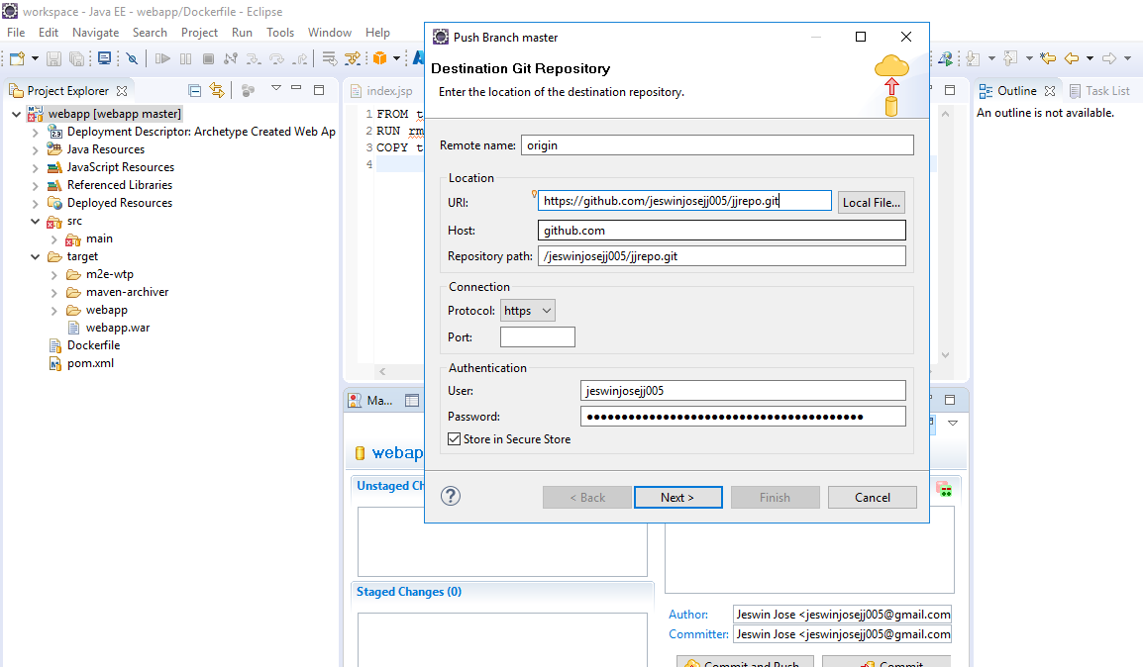

**Push to remote repo success-C1**

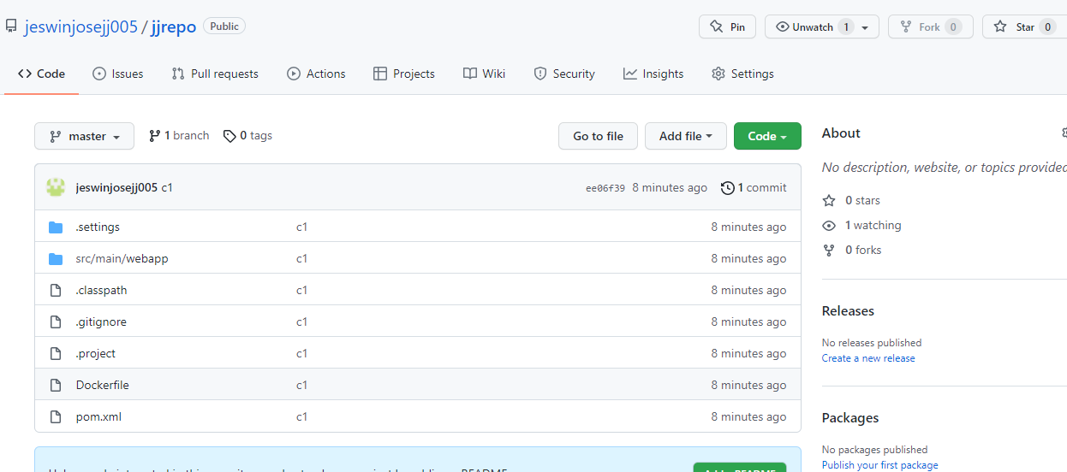

**Made changes and pushed again -C2**

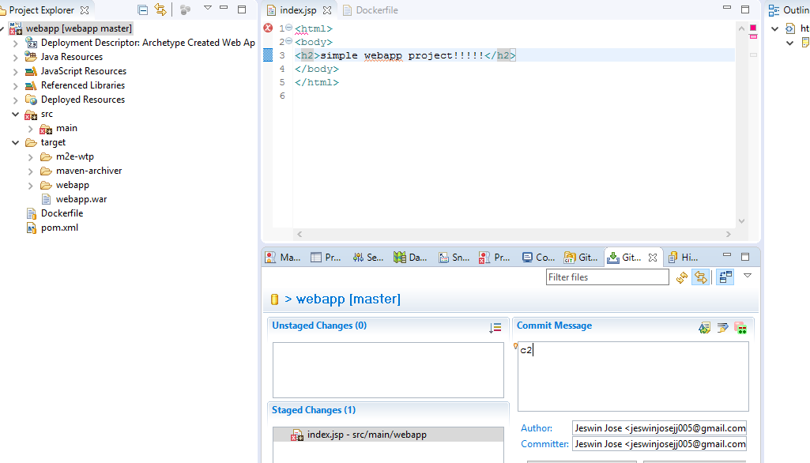

**Docker containerization**

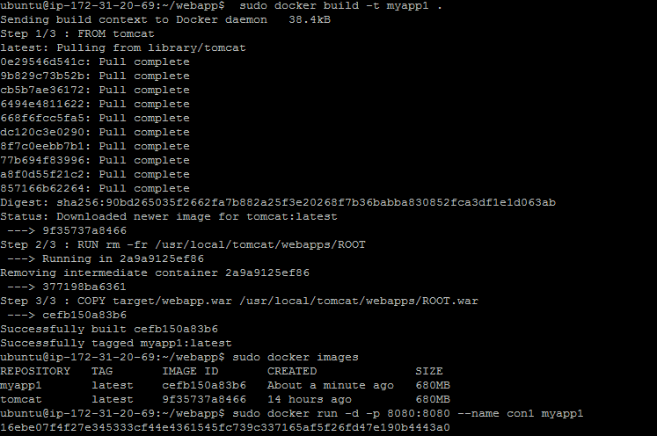

**Pip install aws modules**

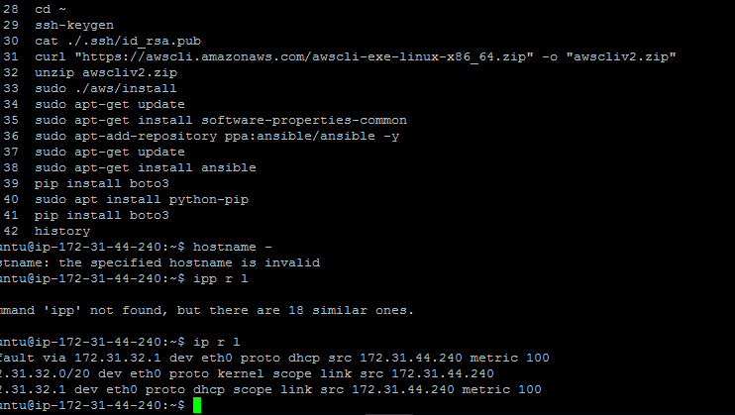

**Aws configure for ubuntu**

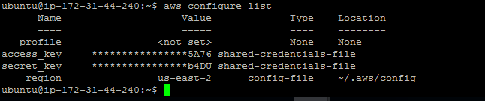

**Scripts are pushed to remote repo https://github.com/jeswinjosejj005/jjrepo.git**

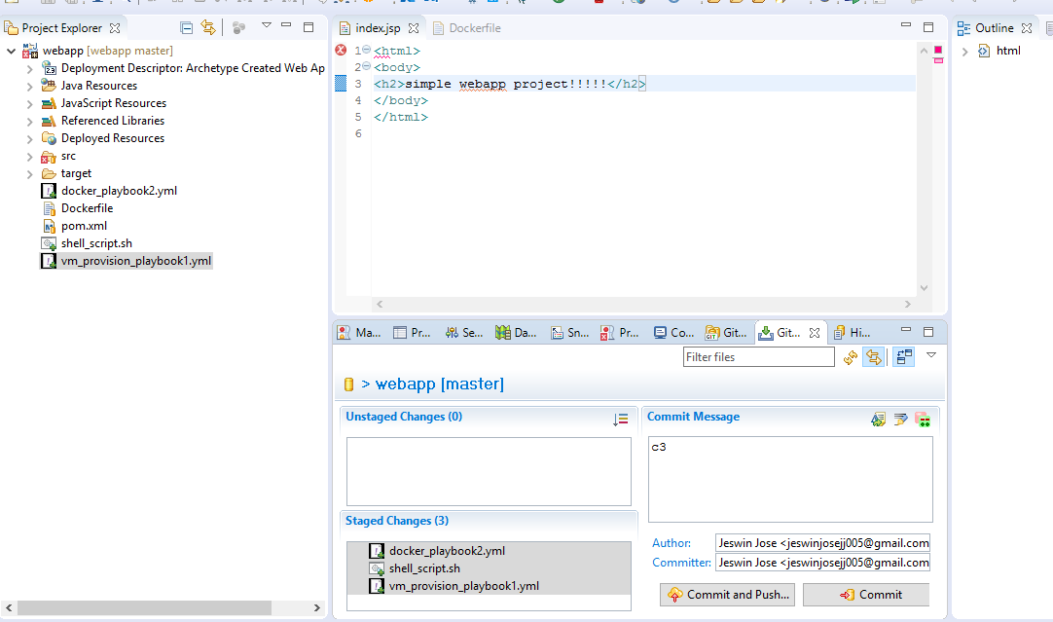

**Vm_provision_playbook1.yml to create new vm-----success**

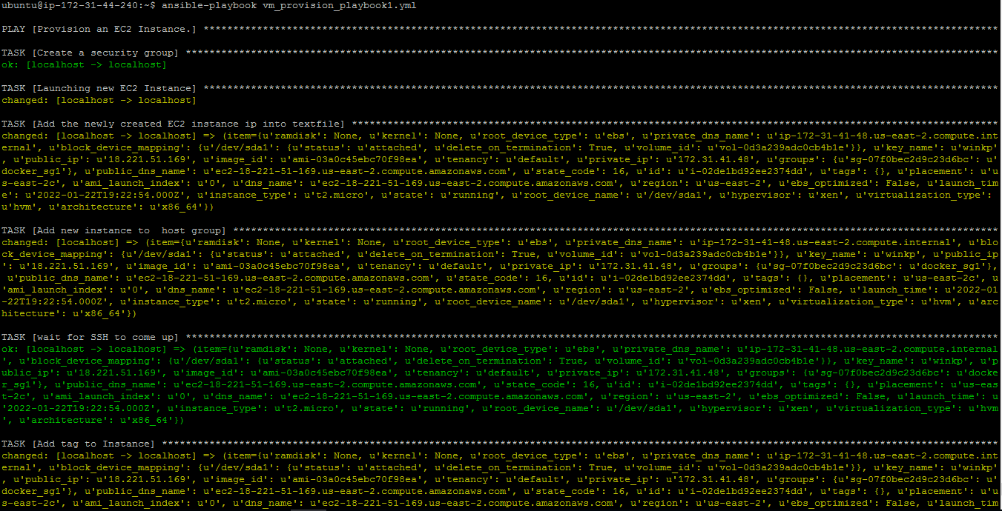

**shell_script.sh for copying new vm name----success**

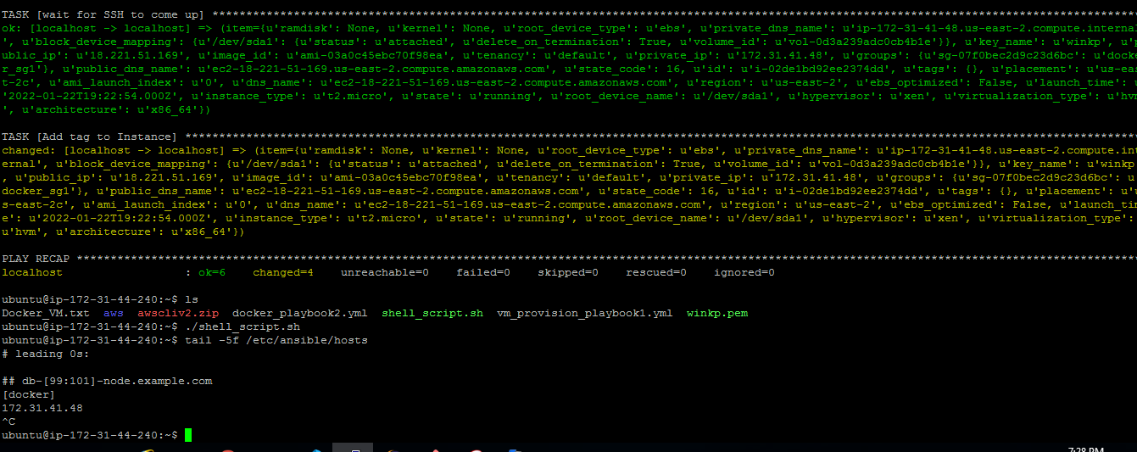

**Cross-verifying ip of vm with shell script copied ip----correct**

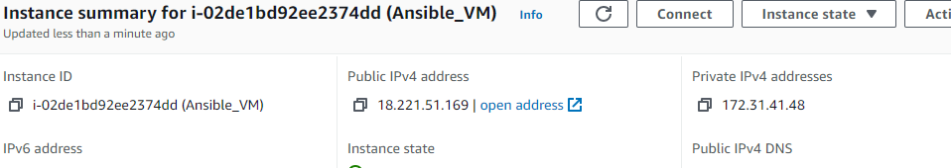

**Docker_playbook2.yml-----success**

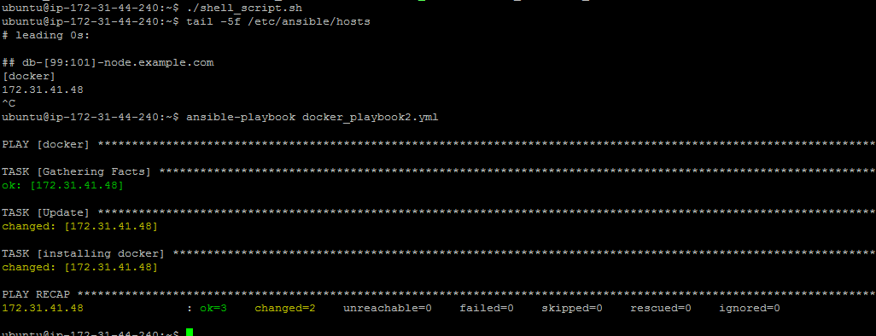

**Configured global tool configuration: mvn,jdk**

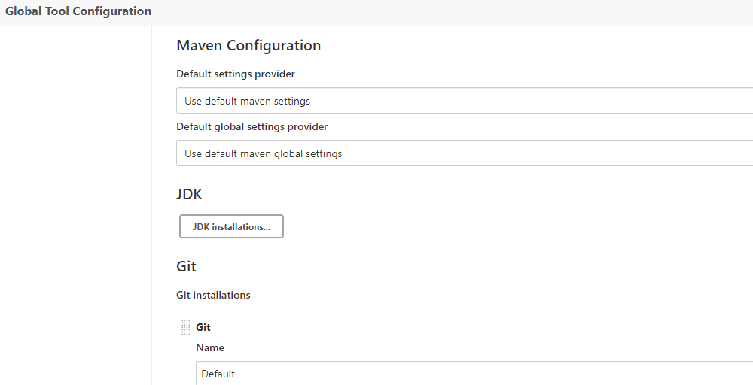

**Created docker repo**

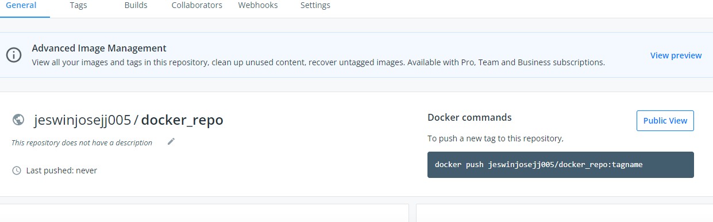

**Pipeline1**

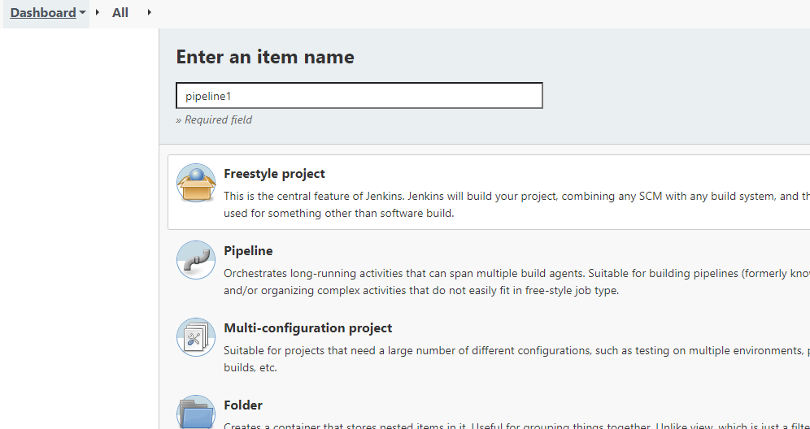

**Restricting Pipeline1 to VM2**

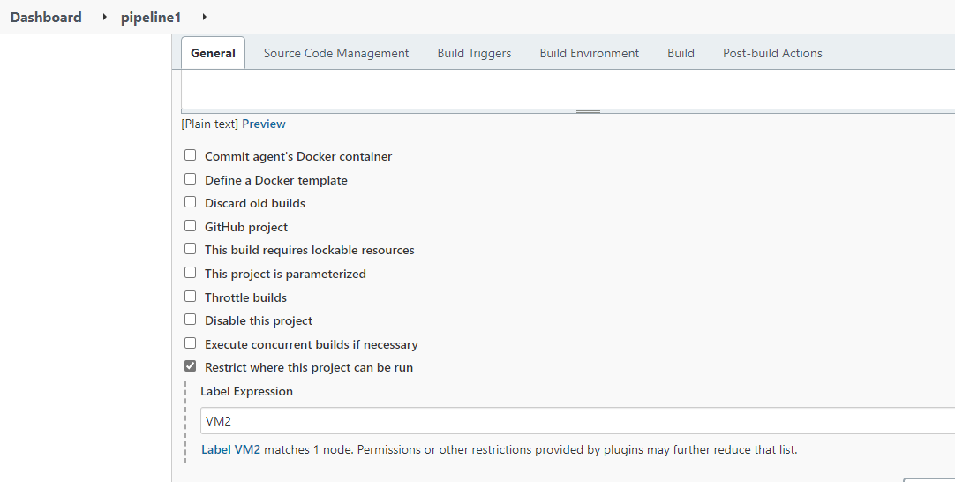

**Source code management**

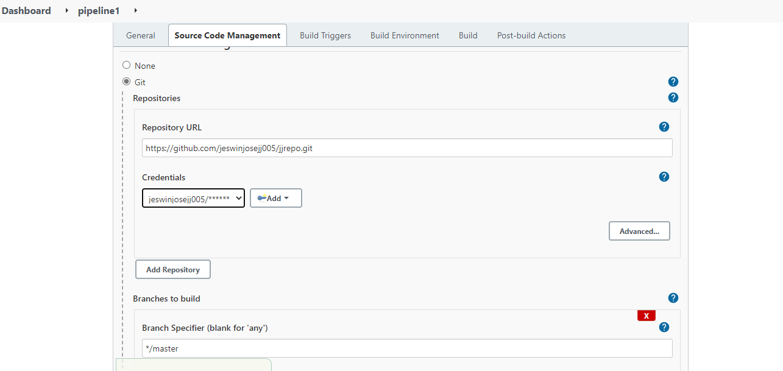

**Maven Build**

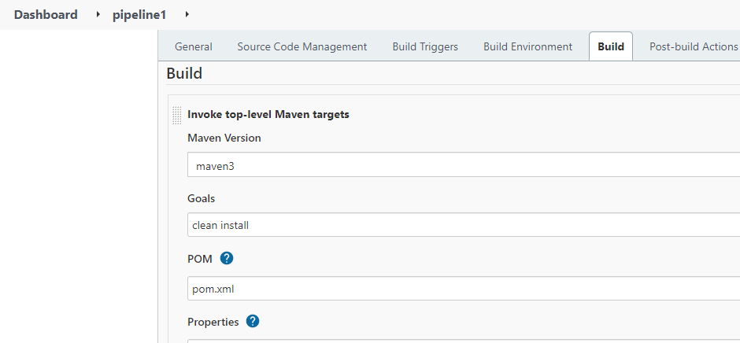

**Build—pushing to docker hub**

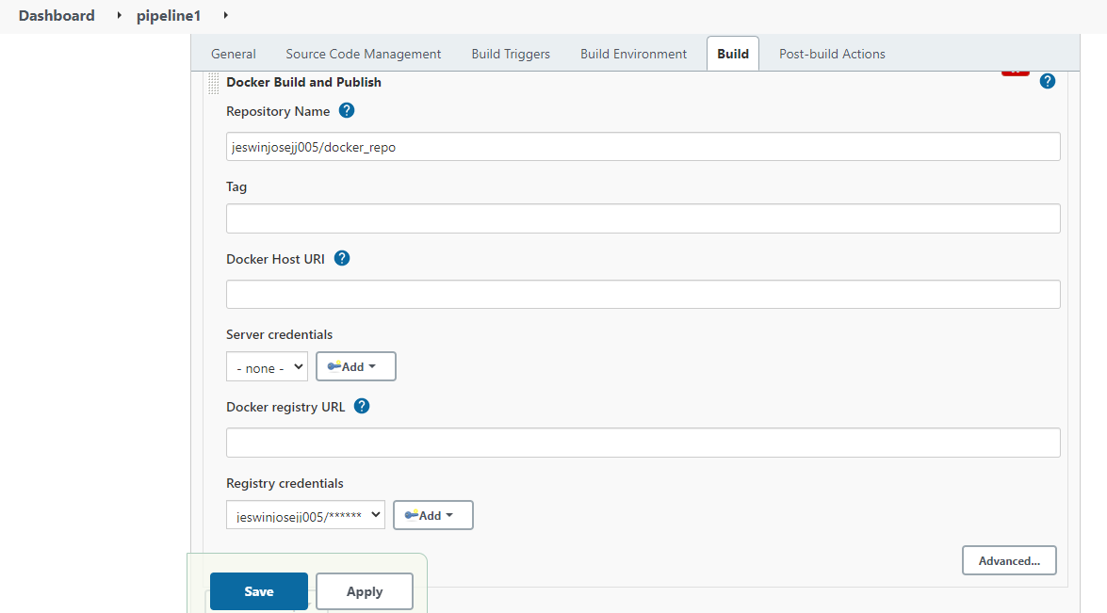

**Console output------success(pipeline1)**

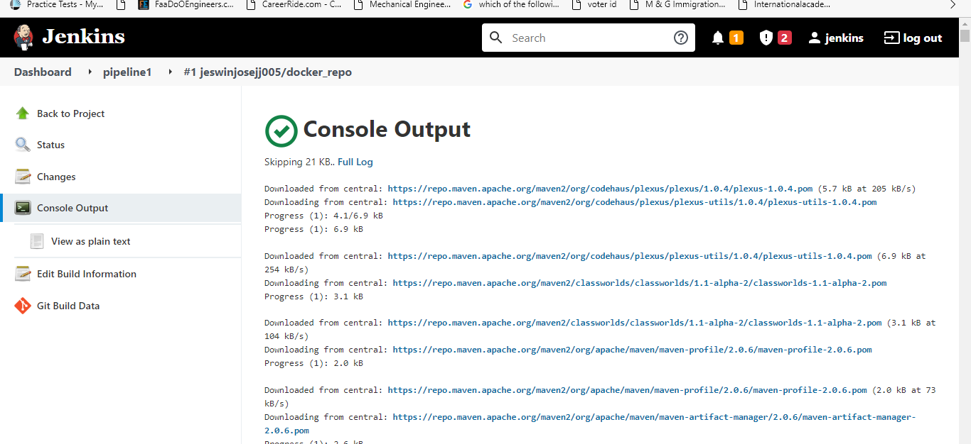

**Success**

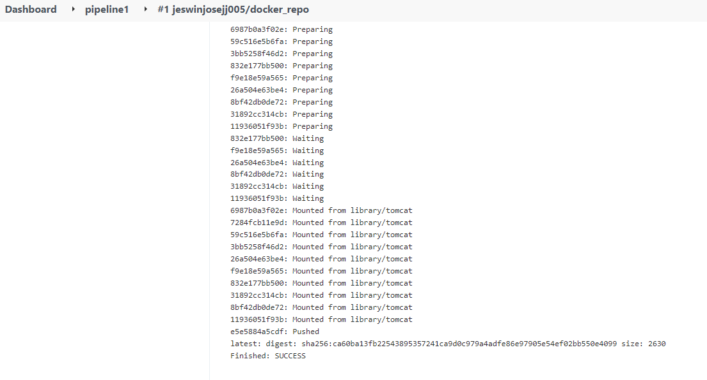

**Pipeline 1 successfully run on VM2**

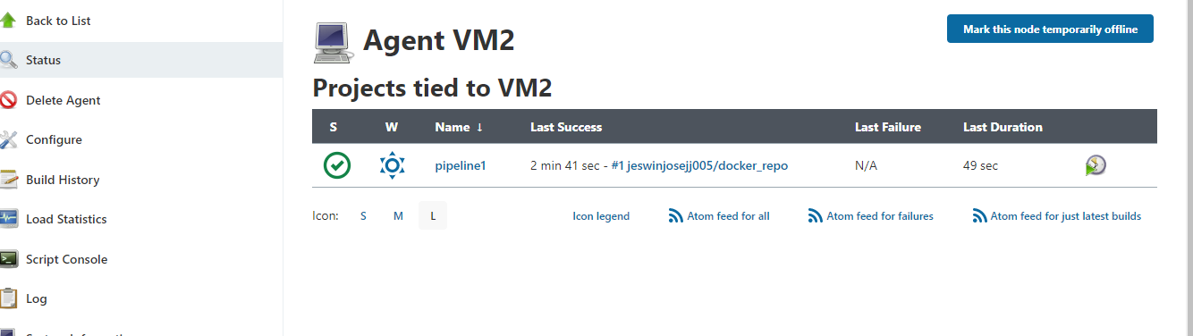

**Image been Successfully pushed to Docker hub**

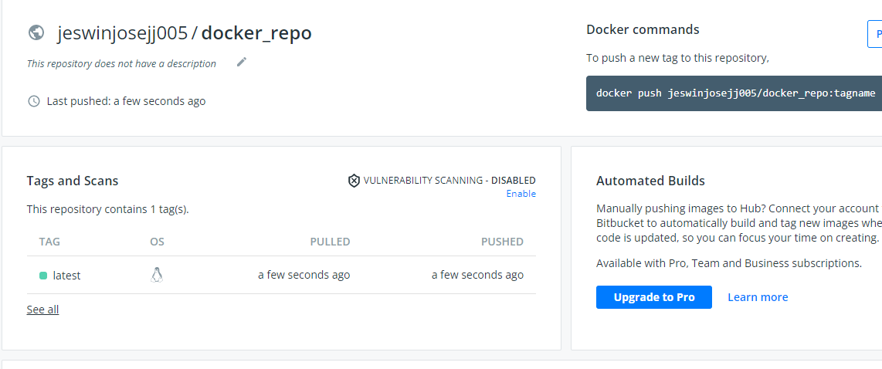

**Webhook**

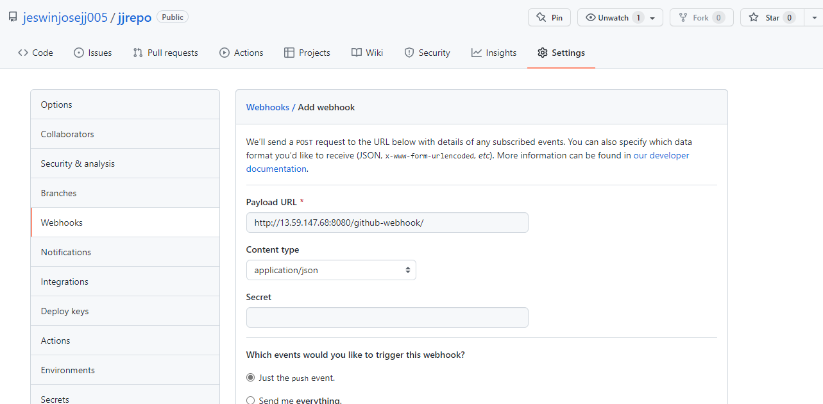

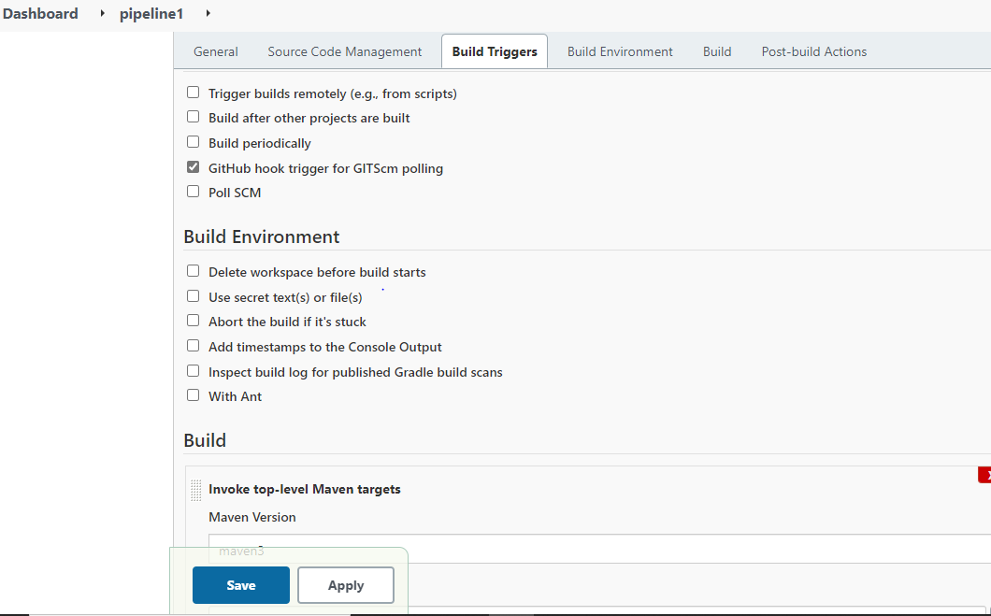

**Pipeline2**

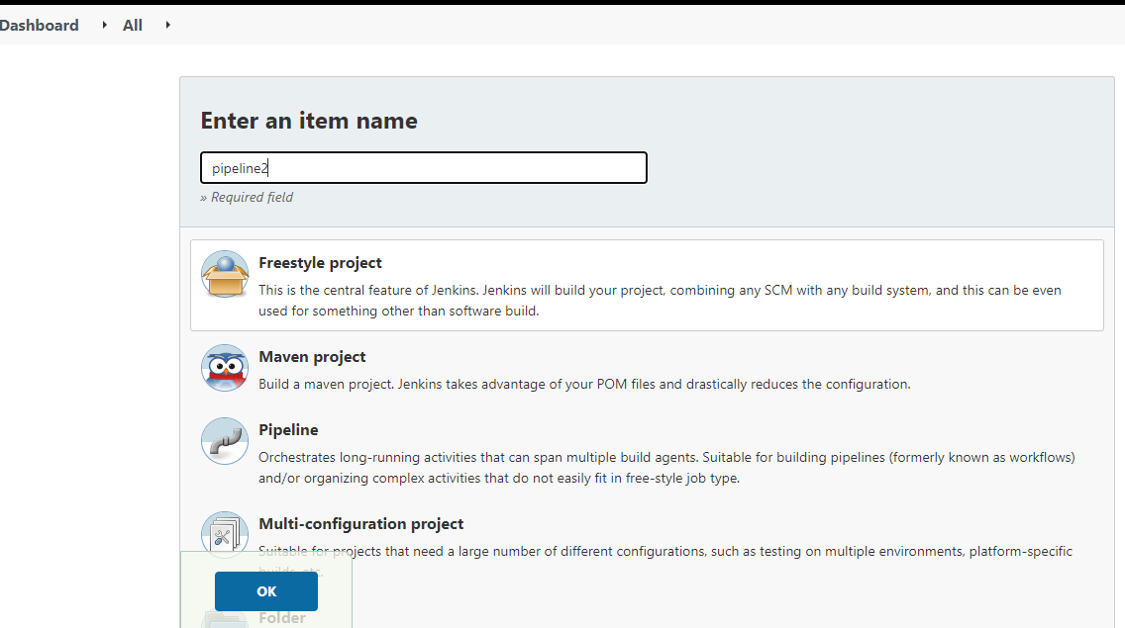

**Build-Trigger to run right after pipeline1**

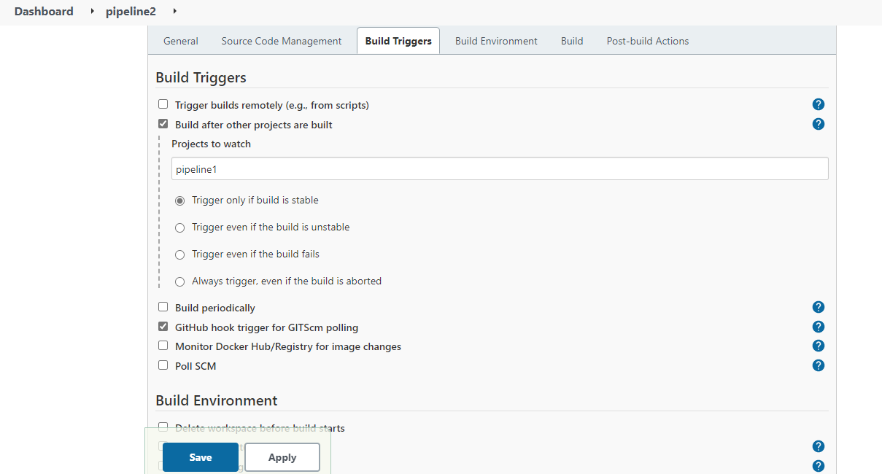

**Build –running script to create new vm and copy ip to host file**

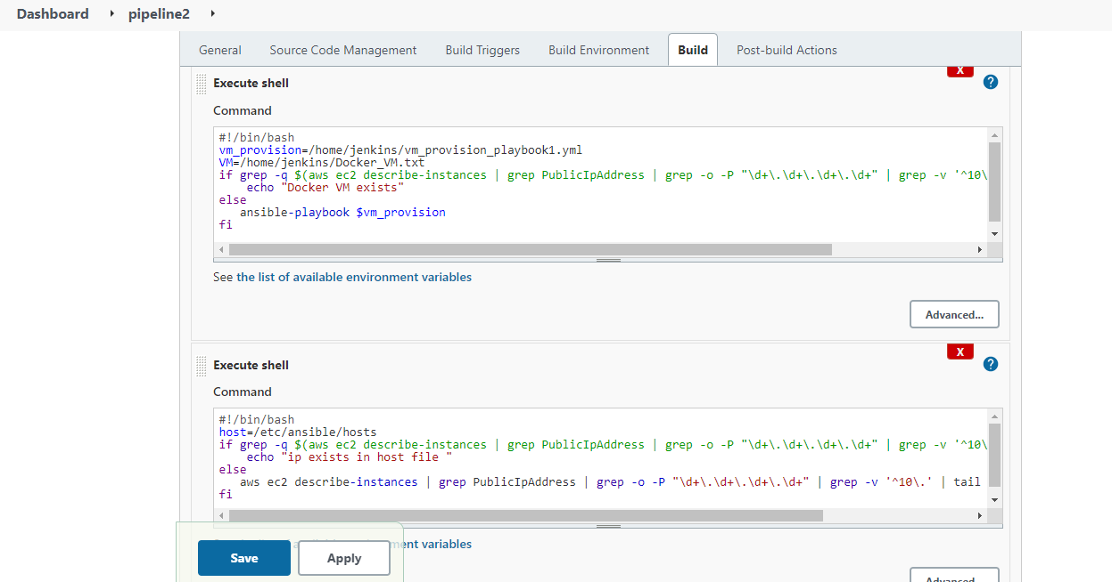

**Build---invoking playbook2 for installing docker and run pull and deploy container from docker hub**

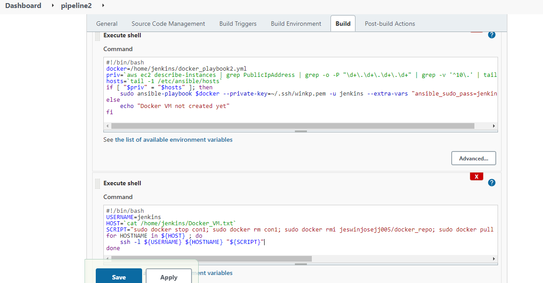

**Success**

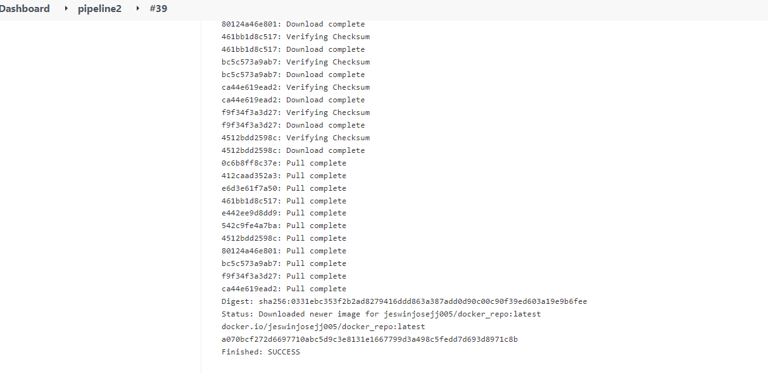

**Successful Final output**

